# INTRODUCTION

* 1. Overview
  2. Bright Ideas are a company specialising in offering help and support to organization requiring assistance to deliver their development program and ambitions.
  3. Purpose
  4. Specifically it has three main aims: 1 To offer leadership on an interim or short term basis to drive delivery of your development program and goals 2 To offer high level assistance on projects, programs, staffing or strategic issues - when you need it 3 To produce homes for sale Bright ideas is owned by Martin.

1. **Problem Definition & Design Thinking**
   1. Empathy Map

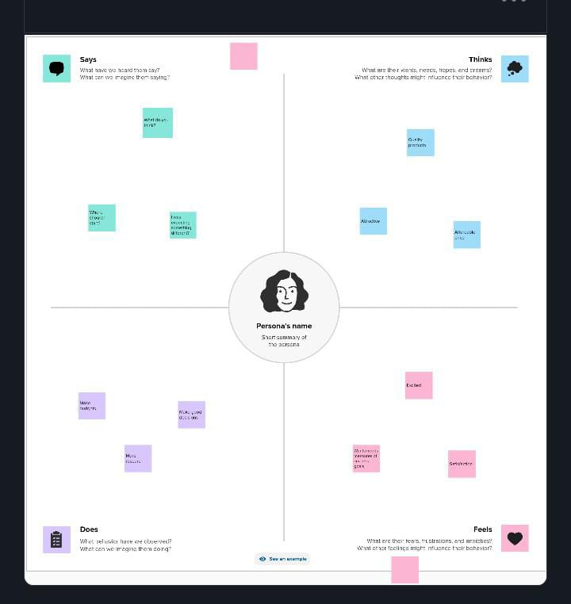

* 1. Ideation & Brainstorming Map

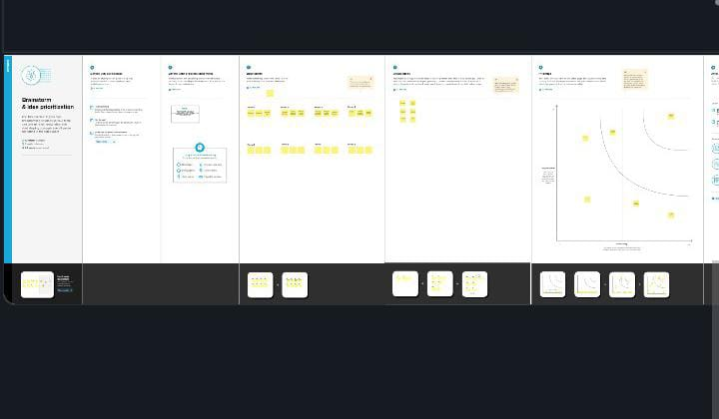

# RESUL

# img db.jpg

# ADVANTAGES & DISADVANTAGES

# confidence

# competence

# credibility

* Difficulties with objectivity – unable to extricate themselves from the Organisational culture and politics.
* May have their own preconceptions.
* Credibility undermined due to previous organisational position (too junior) and constrained by position in company hierarchy.
* May choose to avoid difficult issues.

# APPLICATIONS

# Engage your workforce across the world. Break down entrenched silos and geographic barriers. Foster a global, company-wide culture of innovation. Brightidea’s advanced idea & innovation management software lets you crowdsource on a grand scale

# CONCLUSION

# If office walls could talk, innovation may be one of the most overused buzzwords in the workplace today. Prior to the economic downturn, innovation drove new business lines across the marketplace. But when turmoil hit and companies slashed budgets to stay afloat, leaders also cut ties with their innovation strategies.

# FUTURE SCOPE

He resulting report, *Creating the Conditions for Sustainable Innovation,* defines innovation as a new solution (product, process, or business model) that drives differentiation and measurable business value..